LOGO

Documentation for the Interoperability
Management and Audit System (IntMAS)

Version 1.0
approved on ??? by ???
DOCUMENT information
Organization | <…>  <…>  <…>
Title | Documentation for the  Interoperability Management and Audit System (IntMAS)
Version | 0.91
Date

Authors and Reviewers
Author(s) / contributor(s) | Name (organization)  Name (organization)
Approver(s) | Name (organisation)  Name (organisation)

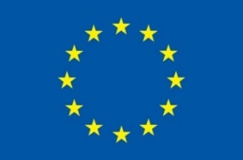 | Development of the IntMAS methodology and label has been funded by the European Union’s Horizon Europe Research and Innovation Programme in the int:net project under Grant Agreement no 101070086.

Abstract
This document is ...

DISCLAIMER
The opinion stated in this document ….

CONTENTS
CONTENTS 4
1 Motivation 6
2 Implementation Process 6
3 Assessment of Interoperability Status 6
4 IntMAS Implementation Results 7
SUB-DOCUMENT 1: INTEROPERABILITY POLICY 8
Example 10
SUB-DOCUMENT 2: INTEROPERABILITY PERFORMANCE PROGRAM 12
1 Summary 13
2 Targets and Action Program 13
Example 15
SUB-DOCUMENT 3: INTEROPERABILITY MANAGEMENT SYSTEM 16
1 Introduction 17
2 Organisation 17
3 Policy, targets and actions 17
4 Legal Compliance 17
5 Rules and processes to comply with policy and program 17
5.1 Management of resources 17
5.2 Product and service development 17
5.3 Testing and validation 18
5.4 Marketing and communication 18
5.5 Training and capacity building 18
5.6 Networking and cooperations 18
5.7 Procurement 18
5.8 Business development 18
6 Communication, Documentation and Training 18
6.1 Internal communication 18
6.2 External communication 18
6.3 Control of documents 18
6.4 Maintaining legal register 19
7 Monitoring and controlling 19
7.1 Direct interoperability effects 19
7.2 Indirect Interoperability effects 19
SUB-DOCUMENT 4: INTEROPERABILITY PERFORMANCE STATEMENT 20
1 The organisation 21
1.1 Administrative units relevant for interoperability 21
1.2 Tasks related to interoperability 21
1.3 Interoperability aspects and impacts of the operation 21
1.4 Interoperability success stories 21
2 Interoperability Policy 21
3 Interoperability Management 21
4 Interoperability Performance Program 21
ORGANISATIONAL INFORMATION 22
6 External verification 24
6.1 Date and statement of validation 24
6.2 IntMAS validation result 24
6.3 Date of next validation planned 24
6.4 Registration certificate 24
7 Contacts 25
8 Glossary 26
List of Tables 27
List of Figures 27
List of Abbreviations 27
A. Annex: Results of Assessment yyyy 28
B. Annex: … 29

Motivation
Our organization implemented the Interoperability Management and Audit System (IntMAS) because ???

Implementation Process
IntMAS has been implemented for the first time from ??? to ???. The overall implementation process is depicted in Fig. 1.
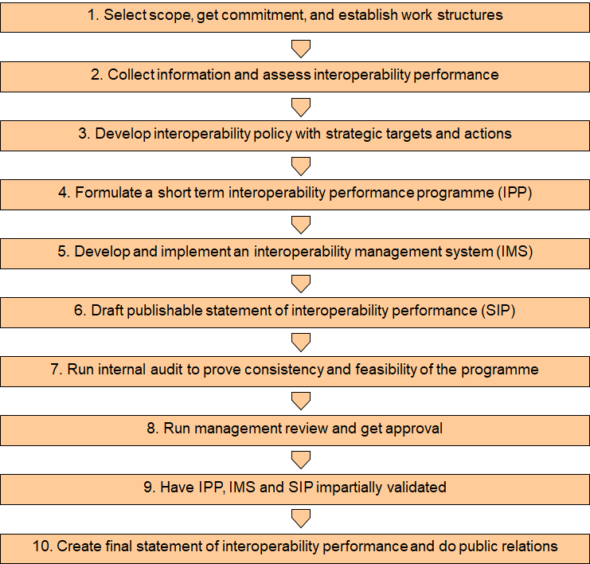
Steps in the first cycle of the IntMAS process

Assessment of Interoperability Status
We decided to assess and monitor the status and development of the interoperability performance of the organisation using EMINENT (“Evaluating the Maturity of INteroperability in the ENergy Transition”). The tool helped analysing the capabilities – or skills – that are required for our organisation to effectively foster, develop and implement interoperable solutions.
As an example, the following shows some results from the test exercise with the Semantic Interoperability Framework (SIF) community. The area of expertise of the participating experts in terms of the SGAM framework can be found in ???. Due to the fact that the SIF community focusses on home energy management products, it makes sense to see most respondents have expertise in the DER and Customer domains.

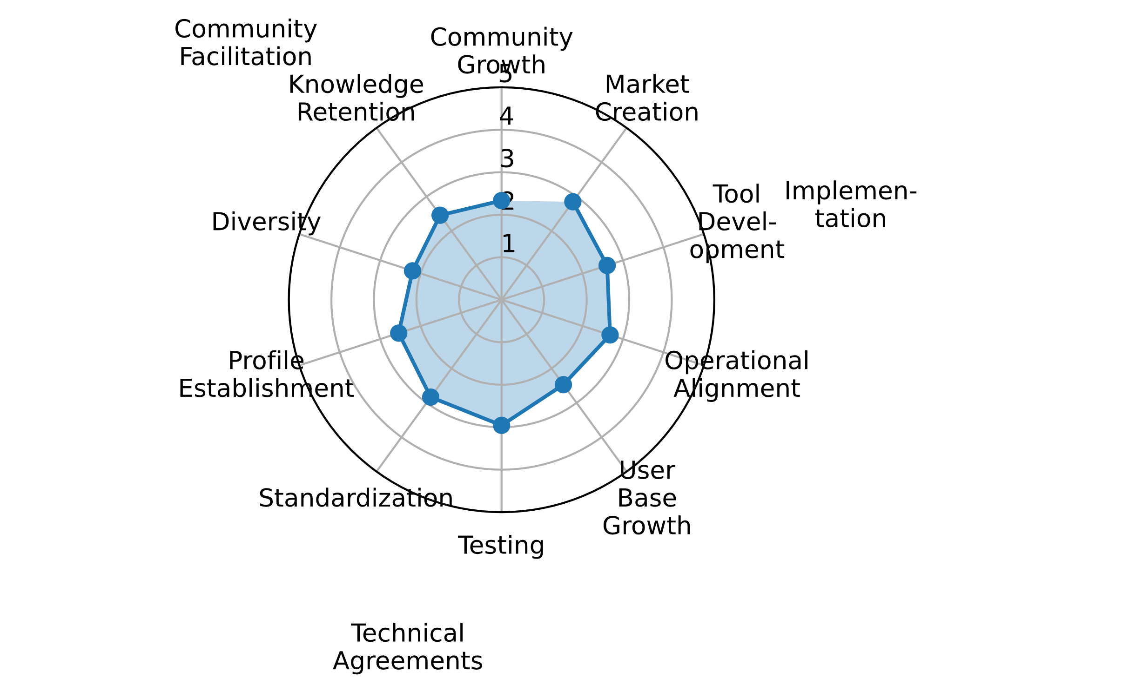
Overview of Interoperability maturity

IntMAS Implementation Results
Main results of the IntMAS implementation process are the following documentations:
- IPS: Interoperability Performance Statement (cf. page 20),
summarizing the 3 management documents IP, IPP and IMS
- IP: Interoperability Policy (cf. page 8)
- IPP: Interoperability Performance Program (cf. page 12)
- IMS: Interoperability Management System (cf. page 16).

SUB-DOCUMENT 1:
INTEROPERABILITY
POLICY



We are an organization that ….

Our overall goals with respect to interoperability in the energy system are:
- X
- X
- X.

To achieve these goals, we pursue the following strategic policies:
- Y
- Y
- Y.

This Interoperability Policy has been approved by <head of organisation> and < the Board of Directors> on <date> ...

We recognise that in addition to this Policy Statement, actions and management assignments are needed. To help with putting the interoperability policy into practice and achieving continual improvements of interoperability performance, an interoperability management system according to the IntMAS guideline has been developed.

Example
(remove from the organisation’s version)



We are an organization that brings forward energy transition by consultancy and research, development and innovation support.
Our overall goals with respect to interoperability in the energy system are:
- help crossing boundaries between energy and technology sectors
- bring people together that can build and jointly drive interoperable systems and communities
To achieve these goals, we pursue the following strategic policies:
- Participate in international and transnational projects related to dataspaces and broad interoperability
- Keep developing our consultancy USP in advanced energy solutions for energy management in companies and municipalities
- Offer world-class platforms for the establishment of communities in interoperability for the future electrical, heating and mobility sectors.

SUB-DOCUMENT 2:
INTEROPERABILITY
PERFORMANCE
PROGRAM

- Summary
xxxx

Targets and Action Program
For the period from <start> to <end> the following targets and actions have been decided:
Significant impacts | Targets | Activities | Time frame | Responsible person
The … Department
The … Department

Example
(remove from the organisation’s version)
Significant impacts | Targets | Activities | Time frame | Responsible
Department: Research and Development and Innovation
consistent governance for interoperability | long lasting Interoperability Community established by Oct 25 | prepare and run The Think Tank event in Vienna on Jun 25 with min 15 experts from all governance classes | Apr – Jun 25 | LK
consistent governance for interoperability |  | develop and introduce IntPPC in existing int:net community | Mar – Aug 25 | AT, AC
systemic interoperability in a diverse ecosystem | IntMAS deployed in 10 organisations by end of September 2025 | implement IntMAS in B.A.U.M. | Mar - Apr 25 | LK, MS
systemic interoperability in a diverse ecosystem | IntMAS deployed in 10 organisations by end of September 2025 | support 3 partners w/ intMAS | Apr – Jun 25 | LK, CA
systemic interoperability in a diverse ecosystem | IntMAS deployed in 10 organisations by end of September 2025 | support 3 companies w/ IntMAS | Apr –Aug 25 | LK
systemic interoperability in a diverse ecosystem | IntMAS deployed in 10 organisations by end of September 2025 | support 3 associations w/ intMAS | Apr – Aug 25 | CA
systemic interoperability in a diverse ecosystem | “Int:net approved” label including awarding process established by end of September 2025 | design and register a label | Jan – May 25 | LK, SH
systemic interoperability in a diverse ecosystem |  | develop licensing contract and implement automatic (AI based) validation and awarding | Apr – Jun 25 | LK, AC
systemic interoperability in a diverse ecosystem |  | test licensing and awarding w/ IntMAS test cases | Jul – Sep 25 | CA, AC
interoperability in RDI | mandatory interoperability package in CET Partnership call 2026 ff | support CETP Call Management in formulating interoperability and validation in call 2026 | Oct 25 – Mar 26 | JC
Department: Energy Consultancy for Enterprises
interoperable solutions in corporate Energy Mgmt | advanced technical EMS incl. DSM at BCMB by 1.1.26 | collaborate with landlords of MUC and BER offices to install iMSys, monitor and manage consumption | Dec 25 | RS, MS
interoperable solutions in corporate Energy Mgmt | interoperability standard module offered in ISO 50.001 consultancy by mid of 2025 | close collaboration contract with versatile supplier of standardized EMS solutions | May 25 | MW, MS
interoperable solutions in corporate Energy Mgmt |  | develop 1h training on energy technology standards and systemic interoperability and test in 3 cases | Jun 25 | MS
interoperable solutions in corporate Energy Mgmt | consulters aware of iMSys requirements and potentials for energy Sharing | give Apfelbaum Talk on Metering Systems, legislation and Corporate Energy Sharing | Nov. 25 | LK, MS

SUB-DOCUMENT 3:
INTEROPERABILITY
MANAGEMENT
SYSTEM

- Introduction
xxx

Organisation
xxx

Policy, targets and actions
The overall policy of the organization as well as the targets and concrete actions for the current period are described in the Interoperability Policy (IP) and the Interoperability Performance Program (IUPP) respectively.

Legal Compliance
IntMAS requires an index that includes all legislation relevant to the interoperability domain that the organisation is obliged to observe. The index needs to be updated at regular intervals. In the so-called compliance audit, the organization’s conformity to legal standards, i.e. the observation of this legislation, has been assessed. The following table summarizes the main legal requirements with respect to interoperability. For further documentation check <link to document>.

- Legal conformity
topic | legal requirement | result of check
(source: …)

Rules and processes to comply with policy and program

Management of resources
<Describe which positions and/or persons have a role or responsibility regarding interoperability. Describe if new positions shall be created to meet the requirement of the policy.>

Product and service development
<Describe the processes that involve implementing or fostering interoperability and outline existing/new elements that improve the interoperability performance of the processes. Possibly define procedural instructions to be given to actors.>

Testing and validation
<Describe how you make sure that new products and services comply with defined quality standards.>

Marketing and communication
<Describe how company marketing addresses the interoperability needs of the market and conveys interoperability policy and implementation attempts as well as quality standards to customers and the broad public. Also outline how IntMAS as such and the label shall be communicated.>

Training and capacity building
<Describe the positions in the organisation and their tasks to build capacity with all relevant actors that deal with interoperability performance.>

Networking and cooperations
<Describe what existing network connections you use or which new connections you will establish to support the continuous improvement of the interoperability performance.>

Procurement
<Describe general standards and/or procedural instructions that shall be considered when purchasing components, machinery, tools, services etc.>

Business development
<Outline the processes and tasks that make sure that interoperability will be an intrinsic requirement when developing and communicating the business development of the organisation.>

Communication, Documentation and Training

Internal communication
<Describe how you make sure that all actors that have or may have links to interoperability performance are informed about the policy and program and the related tasks and procedural instructions>

External communication
<Describe the cases and methods to convey the interoperability approaches of the organisation and the related task of the actors. Outline how the existence of IntMAS, mainly the interoperability statement and the respective label shall be used.>

Control of documents
<Describe how you make sure that all documents (starting from IP, IPP, IMS and IPS) are accessible for all relevant persons. Establish and publicize a wiki-style repository or a link-list to easily find key and supporting documents and tools.>

Maintaining legal register
<Describe how you implemented a formal repository – maybe in wiki-style – where all legal requirements and supporting background information is stored.>

Monitoring and controlling

Direct interoperability effects
<Describe processes and task assignments so to monitor outcomes and potential deficiencies of the interoperability approaches and measures. Also describe the requirements and processes of the evaluation exercises during and at the end of the IntMAS implementation cycles.>

Indirect Interoperability effects
<Describe why you believe that with improving and keeping up your own interoperability performance you can / could motivate others to follow.>

SUB-DOCUMENT 4:
INTEROPERABILITY PERFORMANCE STATEMENT

- The organisation

Administrative units relevant for interoperability
<…>

Tasks related to interoperability
<…>

Interoperability aspects and impacts of the operation
<…>

Interoperability success stories
<…>

Interoperability Policy
<copy or summary>

Interoperability Management
<overview of organisational structure, responsibilities, internal and external communication>

Interoperability Performance Program
<overview of targets and actions>

ORGANISATIONAL
INFORMATION

External verification

Date and statement of validation
<…>

IntMAS validation result
<…>

Date of next validation planned
<…>

Registration certificate
<…>

Contacts
<…>

Glossary
<…>

List of Tables
Tab. 1, Legal conformity 17

List of Figures
Fig. 1 Steps in the first cycle of the IntMAS process 6
Fig. 2 Overview of Interoperability maturity 7

List of Abbreviations

- Annex: Results of Assessment yyyy

- Annex: …

